Entire Page: Please change background to this color (white, background 1, darker 5%) –
Font Size 12/ Justified
HOME PAGE Tab
I.
- Retain blue- green color block
- Remove the white color block from “CORLIFE Insurance Agency” (Except the white inside the logo)
- “CORLIFE Insurance Agency” – White
- “We listen. We Solve. We Care.” (Bradley Hand ITC font style) below the logo, white
- Right hand side:
Suite 1204 Antel 2000 Corporate Center
121 Valero Street, Salcedo Village
Makati City
(T) +63 8132502
(F) +63 8131422

II.
- Delete “Our Team” tab except the contents. They will be transferred to About Us.
- Edit “Contact” to “Contact Us”

III.

- Extend photo up to the other end of the page
- Very slow transition or changes only when user goes back to HOME
IV.
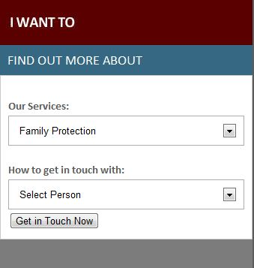

- Delete this portion from the home page. Put this under “CONTACT US” tab

V.

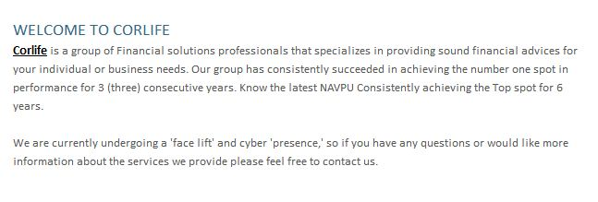
- Remove this part. This will be replaced by previews of “Our Services”.

VI.
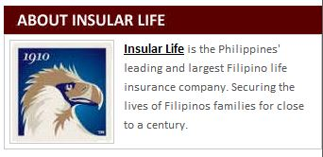
- Heading: Delete “ABOUT INSULAR LIFE”. Replace with
OUR PARTNER- INSULAR LIFE ASSURANCE COMPANY, LTD.

VII.


- This will be included in part V as transition photos .

VIII.

- Remove and replace with Honors Program Qualifiers

IX.
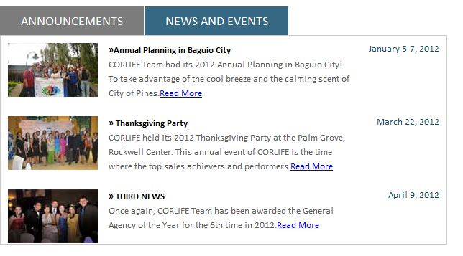
- Remove ANNOUNCEMENT tab and contents
- Under NEWS AND EVENTS, change third news title to ANNUAL AWARDS NIGHT

X.


- Remove Philippine Eagle.
- Replace CORLIFE Insurance Agency with “Stay Connected”
- Retain social media icons: add Twitter, LinkedIn
- Remove contact details on the right side.
- This will appear on all pages

ABOUT US Tab
Photo: Remove group photo and replace with Group photo 1

When user hovers cursor on this tab, drop down menu automatically appears.
Sample only:


When user clicks on an option, it will direct the user on a landing page and the rest of the options will be “click-able” on the left hand side.
Sample only: 

About US drop down menu
- Who We Are
- Meet the Team
- Our Achievements
- Testimonials

Who We Are (contents)
Font size 12 / Justified / Gray font

We are an organization of professional and dynamic financial advisors committed to providing innovative solutions that fit our client’s financial needs. Our fields of expertise include Financial Planning, Estate Planning, Risk Management, Business Planning, Insurance and Investments. Our clientele base includes companies in industries such as banking, securities and stocks, business and real estate amongst others.

In total, our partners have a strong track record of more than 20 years of financial advisor experience. We provide a strong foundation, access, expertise and credibility to clients who seek options to grow and diversify their investments.
Our Vision

Our Mission

Core Values
In the practice of our profession, we are guided by the following values:
- Integrity. We are committed to do our business with utmost professionalism and of highest ethical standards.
- Excellence. We are committed to provide quality solutions to financial concerns of our customers. We are dedicated to continuously enhance our knowledge and skills for the benefit of our clients.
- Commitment. We are faithful to our promise to provide our customers what is needed.
- Teamwork. As a team of professionals, we value each other’s contribution in the team. Our goal is achieved collectively.

Meet the Team Tab
Transfer all contents from the previous “The Team”

Under Agency Leaders:

Nunnatus A. Cortez, ECE, LUTCF, RFC, AchFP
Chief Executive Officer and Chairman of the Board
Toots has been helping people for 24 years. His wealth of experience in financial planning and benefits program design has served a wide segment of clients ranging from multinational firms to leaders of industry to licensed professionals.
A licensed Electronics and Communications Engineer, he was among the company’s first Registered Financial Consultants (RFC) and Associate Chartered Financial Planners, (AChFP). For the past 24 years, he has continued to upgrade his investments, risk management and estate and financial planning knowledge and skills to better serve clients. He has also trained with the PSE-I Academy. To stay current, he religiously attends international and local industry conventions.
His personal achievements include Underwriter of the Year in 2007, 2009, 2011, three- time Wealth Series Underwriter and three- time Divisional Underwriter of the Year. He also maintains qualification to the Million Dollar Round Table (MDRT), an international organization of Top 6% Financial Planners worldwide for 13 years. He is also two- time COURT OF THE TABLE (COT) and three- time TOP of the Table (TOT).
Toots is currently the Chairman of the Board of CORLIFE Insurance Agency and also serves as President and CEO of CORLIFE Financial Consulting, Inc., President of the Antel Corporate Center Unit Owners Association and Director of the Makati Rotary East.
Despite all these achievements, Toots stays amiable, approachable and grounded. He lives on a personal mantra: My client’s concerns are my concerns.

Myrna R. Cortez
President
Before joining the financial consultancy work, she worked for eight years in various foreign-assisted projects. She was designated as Deputy Project Director for a World-Bank grant project. Her background in accountancy helped her evaluate local projects and proposals needing funding from foreign donors.

Her extensive training and experience in the areas of organizational development, project management, planning, systems development, project monitoring and evaluation as well her background in working with foreign-assisted projects has made her accustomed to various aspects of office operations. As a matter of fact, she set-up offices in various provinces of the country as base of operations. Because of her wealth of knowledge and hands- on training, she, along with Toots, was able to set- up CORLIFE office without breaking a nail.

Under Management Team:

- Copy/ Paste Profile of Toots’ and Myrna’s profile.
- Put new group photo heading – see attached.

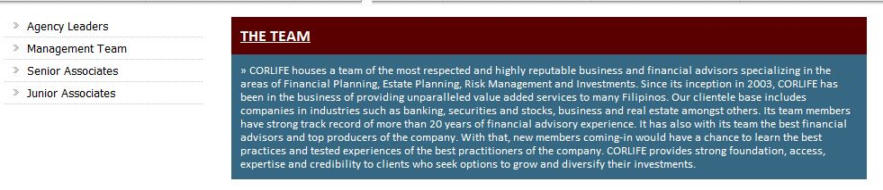

“The Team”: Remove underline
Increase font size to 12, including contents.
Remove the maroon color block, and make the word “The Team” color blue.
Contents: “CORLIFE houses a team of the most respected…” – please make this gray too.
Remove blue color block

When a selection on the left side panel is clicked, a submenu will pull down displaying the names of the persons.

Example1: When Agency Leaders is clicked:

Agency Leaders
- Nunnatus A. Cortez
- Myrna R. Cortez
Management Team
Senior Associates
Junior Associates

Example2: When the “Management Team” is clicked:

Agency Leaders
Management Team
- Nunnatus A. Cortez
- Myrna R. Cortez
- Jerone Alvin C. Zenarosa
- Anna C. Canlas
Senior Associates
Junior Associates

COPY all their respective profiles. All of the profiles can be in just one page but when a name is clicked, the page will automatically scroll down to the advisor’s personal profile.

Remove this portion:
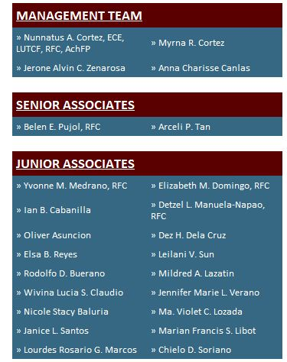

Save this portion as this will be moved to “Contact Us”


Under Our Achievements Menu:
Since our inception on March 2003, we have been awarded the following by Insular Life Assurance Company, Ltd.

2004 Rookie General Agency of the Year
2005 General Agency of the Year
2006 General Agency of the Year
2007 General Agency of the Year
2008 General Agency of the Year
2009 Runner-up General Agency of the Year
2010 General Agency of the Year
2011 General Agency of the Year

The General Agency Award is the highest distinction Insular Life awards to a general agency with the highest first year premium (FYP).

Under “Testimonials” Menu
No testimonials yet.

“Services” Tab
Dropdown menu:
Risk Management
Retirement Planning
Investment Planning
Educational Planning
Estate Planning
Business Planning

Copy all photos and write- ups but format should be vertical. The dropdown menu will be shown on the left side as well. Everything can be placed on a single page and when one menu is clicked, it will automatically scroll down on the specific service.

Under “Business Planning”
What will happen if you can’t mind your own business? How would you like to be in business with your partner’s widow and her children and her new husband? Wouldn’t it make more sense to have a mandatory buy and sell agreement funded with life insurance that would remove the uncertainty for both the decedent’s family and the surviving owner? We have answers for you. We provide advice on how your company would continue operating in case one of the owners or key man dies.

- Business Succession Planning
- Key Management Insurance
- Group Benefits Planning
- Employee Stock Ownership Plan
*Remove color blocks and make the ones in bullet form color blue (same color as “Business Planning”)
Place this on the left hand side of the Services Screen so that user will stay on the same page can make immediate action.

Under “Careers” tab

Our Commitment
We commit to arm and propel you to a level of growth you want to have! By joining us, you will have the opportunity to learn tried and tested ideas from our successful senior advisors whose evaluated experiences in this business are unselfishly shared. We value everyone in the team. We support and encourage everyone to reach their growth potential.

Financial Planner

As a CORLIFE Financial Advisor, you will have the opportunity and full autonomy to run your business as an independent entrepreneur while still keeping abreast with the financial market, latest investment strategies and investment vehicles. You will be the professional who will guide clients every step of the way in making wise financial decisions in order to achieve financial success. Their business will be your reward and you will reap these through unlimited income, free travel, and recognition from locally and internationally acclaimed organizations.
Job Posting
- Financial Advisor – (5) slots open

Management Team

Are you good in handling and directing people? Do you have the skills to motivate individuals to reach their growth potential? Then you must be in our management team! Be one of the people who would help the company expand and achieve its vision through careful planning, implementation and evaluation.

Job Posting
- Sales Manager – (5) slots open

Business Support

Wanting to work in an employee- friendly environment for the longest time? Then look no further! CORLIFE Business Support team houses the friendliest staff. Be one of the persons who coordinate and support the clerical needs management team. Unleash your creativity by arranging events and other company engagements.

Job posting
- Administrative Assistant – (0) slots open

APPLY NOW! (Click-able link that leads to a separate window with a short application form)

(Show on separate window)
I want to apply for the position (Please put radio buttons)
() Financial Advisor
() Sales Manager
() Business Support

Name: _____________________________________ (box)
Contact Number: ______________________________ (box)
Ex: +639271234567

E-mail Address: _______________________________ (primary)
________________________________( secondary)
Attach resume

CONTACT US TAB
Dropdown
- Location Map
- Advisor Directory

Under Location Map:
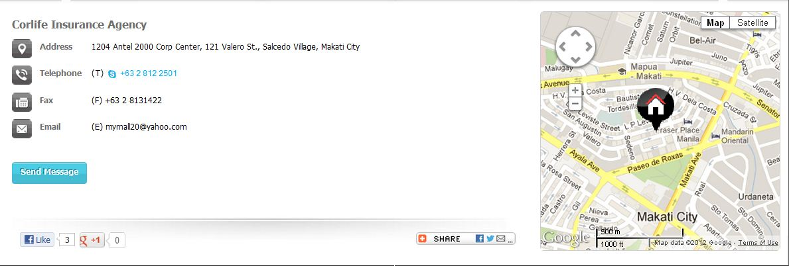
- Remove “send message”

Under Advisor Directory:
Please fix color combinations.

For Part VII.
Slide show of Services
(when one is clicked, it will direct the user to the Services Page where he can find all the services offered by the company. User will automatically land on the option selected.)

FINANCIAL PLANNING RISK MANAGEMENT
Build your wealth from the ground up Protect your family against eventualities



RETIREMENT PLANNING
Prepare for a worry- free retirement



EDUCATIONAL PLANNING
Secure your child’s future today


ESTATE PLANNING
Distribute your wealth and still remain in control


BUSINESS PLANNING
Build a strong foundation for your business


MAKE THE LEAP
Join us and embark on a life changing career


INVESTMENT PLANNING
Take advantage of the economy’s upside potential

For Part VIII.

Please remove EXPERIENCE CORLIFE but instead place:
Congratulations !
- Nunnatus A. Cortez 2011 Underwriter of the Year
2011 Top of the Table qualifier- Life Member, MDRT
National Prestige Club – Executive Level (NPC)
Insular Life Quality Award

- Arceli P. Tan 2011 Qualifying Member – MDRT
National Prestige Club – Qualifying Level

- Belen E. Pujol 2011 Qualifying Member – MDRT
National Prestige Club – Qualifying Level
Insular Life Quality Award

LEAP qualifiers
Elizabeth M. Domingo
Yvonne M. Medrano
Rodolfo D. Buerano
Violet C. Lozada

